DICE GAME
STAGE 1
Things the program should do
welcome user
Input user name
Start game
play diceSimulator
roll dice x 20
Display the result of each roll
Display game finished message that includes user name
is it a use case
use case
Possible case | Actor starts it
Welcome User | No
Input user name | Yes
Start game | No
Play dice simulator | yes
Roll dice | No
Display roll result | No
Display finish message | No

User Case diagram
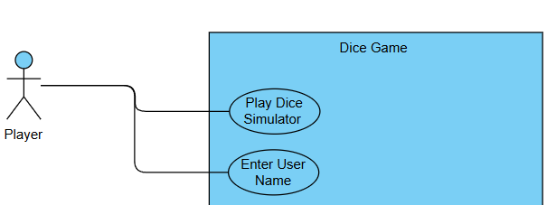
Normal flow only includes what the user sees and does. Aswell as what the system need to fufil the requirement. E.g here is store user name the user never need to know that but the system need to know this.

Use Case description

Enter user Name
Use Case ID | UC-01
Use Case Name | Enter User Name
Created by | Tommy
Actors | Player
Trigger | Player: starts program
Pre-condition | NONE
Post-condition | System:stores userName
Normal Flow | System: displays welcome message  System: prompts player for userName  Player: enters userName  System: stores userName
extends(alternative flow)
Includes

Play Dice Simulator
Use Case ID | UC-02
Use Case Name | Play Dice Simulator
Created by | Tommy
Actors | Player
Trigger | System: userName stored
Pre-condition | System Username stored
Post-condition | System: userName and thank you for playing message displayed
Normal Flow | Repeats 20 time {System: rolls dice  System: displays result of roll}  System: displays userName and thank you for playing message
extends(alternative flow)
Includes

Class Responsibilities Collaborators

GameController
Responsibilities | Collaborators
Create DiceSimulator | DiceSimulator
Holds: simulator (instance of DiceSimulator) | simulator.playDiceSimulator(username)
Holds: userName
Holds userInput(instance of Scanner)
Does: displayWelcomeMessage
Does: getUserName
Does: playDiceSimulator passing uiserName

DiceSimulator
Responsibilities | Collaborators
Create Dice | Dice
Holds: dice (instance of Dice) | dice.rollDice()
Holds: rollResult
Does: playDiceSimulator
(receives userName from Game Controller)
- Action: Repeat 20 times
- Does: rollDice
- Does: displayResult number and value
Does: finishMessage using userName

Dice
Responsibilities | Collaborators
Holds: rollValue
Does:rollDice

